Blue = result

Red = error

|  |  |  |  |  |  |
| --- | --- | --- | --- | --- | --- |
| 1 | 1 | 1 | 1 | 1 | 1 |
| 0 | 0 | 0 | 0 | 0 | 0 |
| 1 | 0 | 1 | 0 | 1 | 0 |
| 0 | 1 | 1 | 0 | 1 | 0 |
| 0 | 0 | 1 | 0 | 1 | 0 |

No Errors

|  |  |  |  |  |  |
| --- | --- | --- | --- | --- | --- |
| 1 | 1 | 1 | 1 | 1 | 1 |
| 0 | 0 | 1 | 0 | 0 | 0 |
| 1 | 0 | 1 | 0 | 1 | 0 |
| 0 | 1 | 1 | 0 | 1 | 0 |
| 0 | 0 | 1 | 0 | 1 | 0 |

ERROR by 1 bit.

|  |  |  |  |  |  |
| --- | --- | --- | --- | --- | --- |
| 1 | 1 | 1 | 1 | 1 | 1 |
| 0 | 0 | 1 | 1 | 0 | 0 |
| 1 | 0 | 1 | 0 | 1 | 0 |
| 0 | 1 | 1 | 0 | 1 | 0 |
| 0 | 0 | 1 | 0 | 1 | 0 |

Can be detected but not corrected.

1. 10011/1010101010, = 1011011100, r=0100.



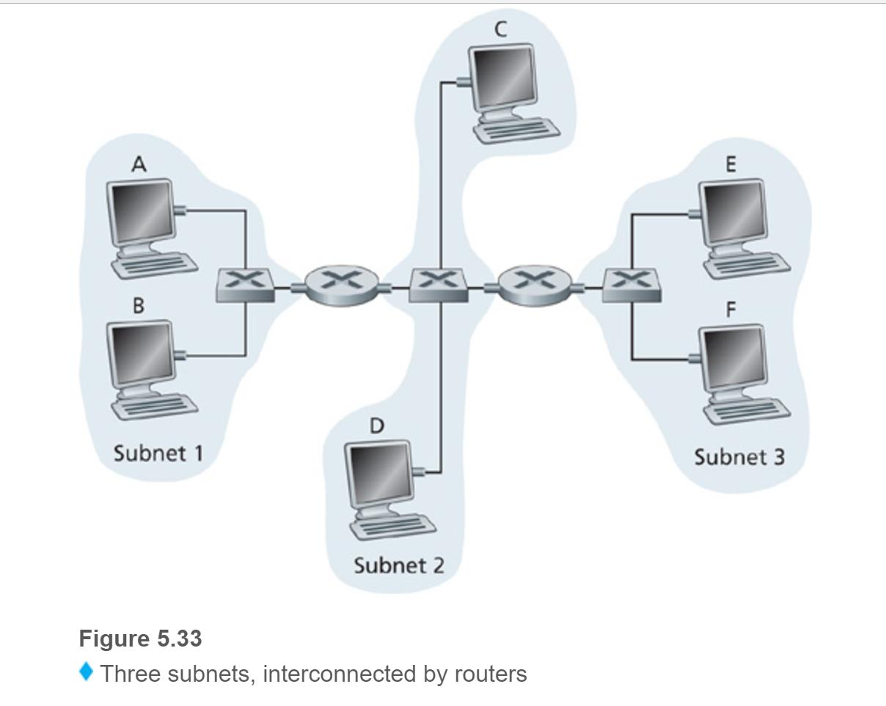

* 1. no, E will see that F is on the same network and so it won’t send it to R1
     1. source ip = E’s ip, destination IP = F’s IP
     2. source mac = E’s mac, destination mac = F’s mac.
  2. No, they aren’t on the same LAN network so it needs a different way. E will need to check B’s IP address.
     1. Source ip = E’s IP, destination IP = B’s IP
     2. Source mac = E’s mac, destination mac = mac of the router connected to E(subnet 3)
     3. Switch 1 broadcasts the ethernet frame to find the ARP address, it learns where A is (subnet 1) and then switch 1 will update it’s forwarding table for A. Yes, Router 1 will receive the ARP message, but it won’t forward it to subnet 3. Host B won’t ask for A’s mac because that was in A’s broadcast. When Switch 1 receives the response, it will add B to it’s forwarding table, then will drop the rest of the frame because A and B are in the same subnet.